**Machine Learning Basics**

ML is the field of study that gives computers the ability to learn without being explicitly programmed. After writing the code, the more the problems the code solves, the better it becomes.

There are majorly 2 types of ML algorithms:  
1. Supervised Learning: It is used the most in real world applications. It refers to algorithms which learn to convert input features (x) to output labels (y). The main characteristic of supervised learning is that the algorithm is given examples with their right answers (correct label y for the given features x), so that it can learn. Then, it is just given x and it has to find y. **Regression** is a type of supervised learning where the algorithm predicts a number out of infinitely many possible outputs. Eg. Predicting the cost of x square feet land using given examples. Another type of supervised learning problem is **classification**. In classification problems, there are finite outputs (usually 2-3). Eg. Is this tumour cancerous or not; has only two outputs, yes or no. In classification, the outputs are called classes or categories. There can be more than 1 x (inputs) used to calculate y.  
2. Unsupervised Learning: In this type, we just give x’s to the algorithm, but not any y. It finds patterns on its own. For example, it can form clusters of data which lie together. Like google news sees all news articles on internet and then groups all similar ones together. It’s called **clustering**. Another application of unsupervised learning is **anomaly detection**. It is used to detect unusual events. Eg. detecting fraud bank transactions. Another use is **dimensionality reduction**. It takes a big data set and reduces it to a compressed data set.

**Regression**

Linear Regression Model

It uses a straight line on a graph to predict the output. Eg.:  
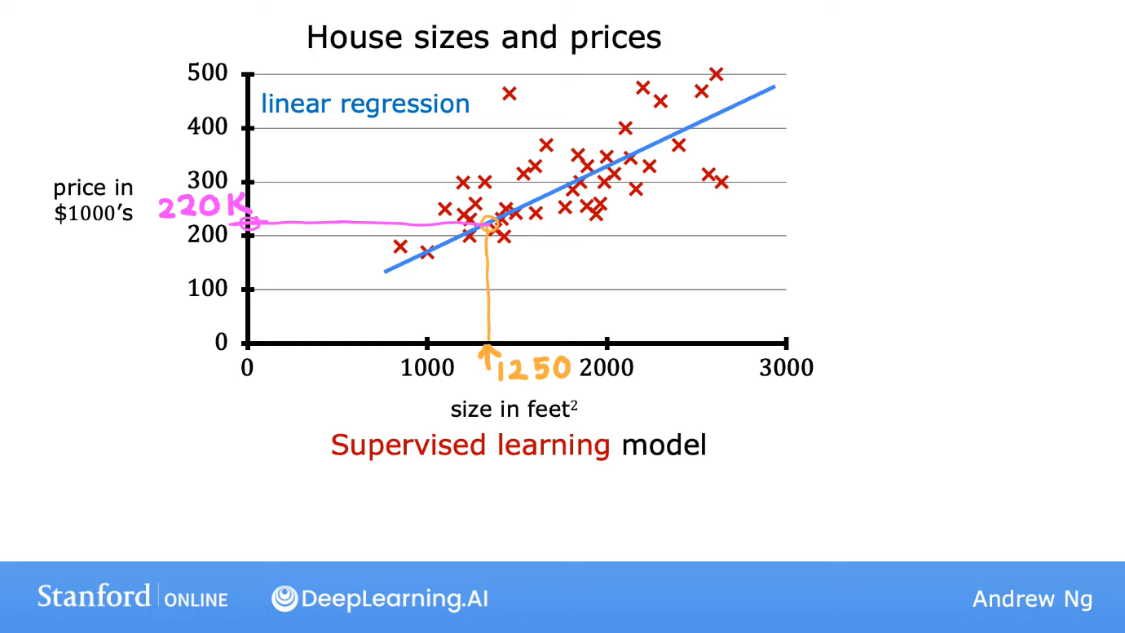  
Here, the red crosses are given sample data. X axis is input and y axis is output. The linear regression algorithm might plot a straight line to predict the output label.

Some terminologies:  
1. Training set: The data set used to train the model.  
2. Feature: The input variable x is called feature.  
3. Label/Target: The output variable or the target variable, y.  
4. m: Number of training examples  
5. (x, y): single training example  
6. (x(i), y(i)): ith training example  
7. f: The learning algorithm receives the training set and produces a function f. f takes the input x and returns ŷ. f is called the model.  
8. ŷ: It’s the prediction of y. It is called prediction. In linear regression, ŷ = fw,b(x) = f(x) = wx+b where w and b are determined using the training set. This formula is for linear regression in one variable (one input). Thus, it is called univariate linear regression.  
9. w and b: parameters or coefficients or weights

How to find w and b so that the line f(x) is close to all he training set points? For that we use a **cost function**. It is a function which measures the error and helps us to choose w and b such that we get the least error. There are many types of cost functions, but the most common one used for linear regression is squared error cost function:  
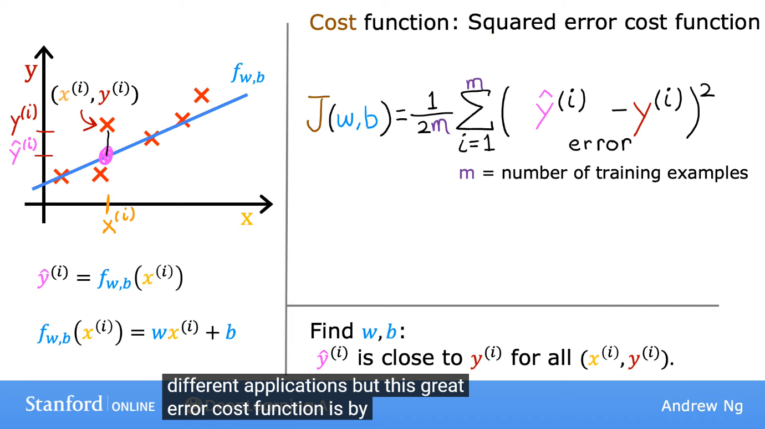  
where, ŷ(i) = fw,b(x(i)). We can imagine the cost function using a 3D graph (or its contour plot) of axes w, b and J respectively for a given training set. But the way of making graphs is not an efficient way to find the correct w and b. There is an algorithm called **gradient descent** to find w and b using code. Gradient descent applies to more general functions including other cost functions that work with more than 1 inputs (x’s).

Gradient Descent Algorithm

Outline:  
 Start with some initial guess for w and b. In linear regression, it doesn’t matter much, what our initial guess is. A common choice is to set both equal to 0. Then, we keep on changing w and b a bit every time to try to reduce J until J reduces to or near a minimum. For some J functions (which are not square error cost functions), there might be more than one minimum. For a square error cost function, there is always one minimum.  
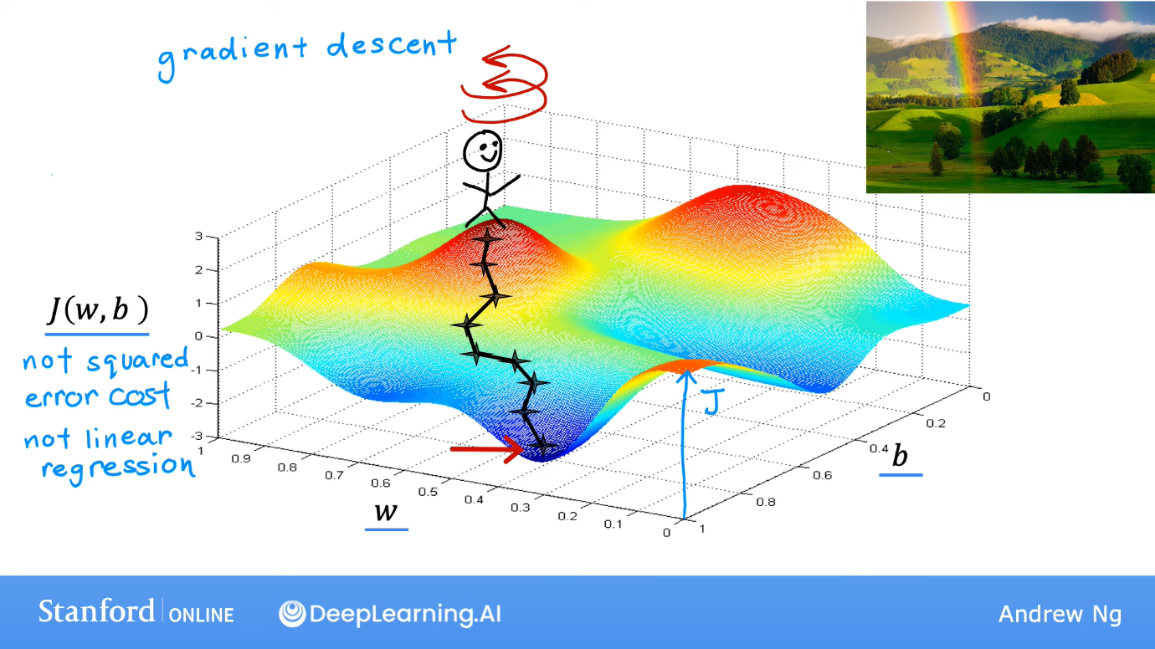  
From the randomly selected (w,b), we need to find the shortest path to reach the valley in the 3D graph (where J is minimum). Mathematically, the shortest path would be of the steepest descent. Then, we descent in that direction. Now, at the new point reached, we again look at all directions and check the steepest descent and then again go in that direction. We keep doing this step by step until we reach the lowest point. But, if we would have chosen another (w,b) initially, we might have ended up in some other minima of the graph. All such points are local minima of the graph.  
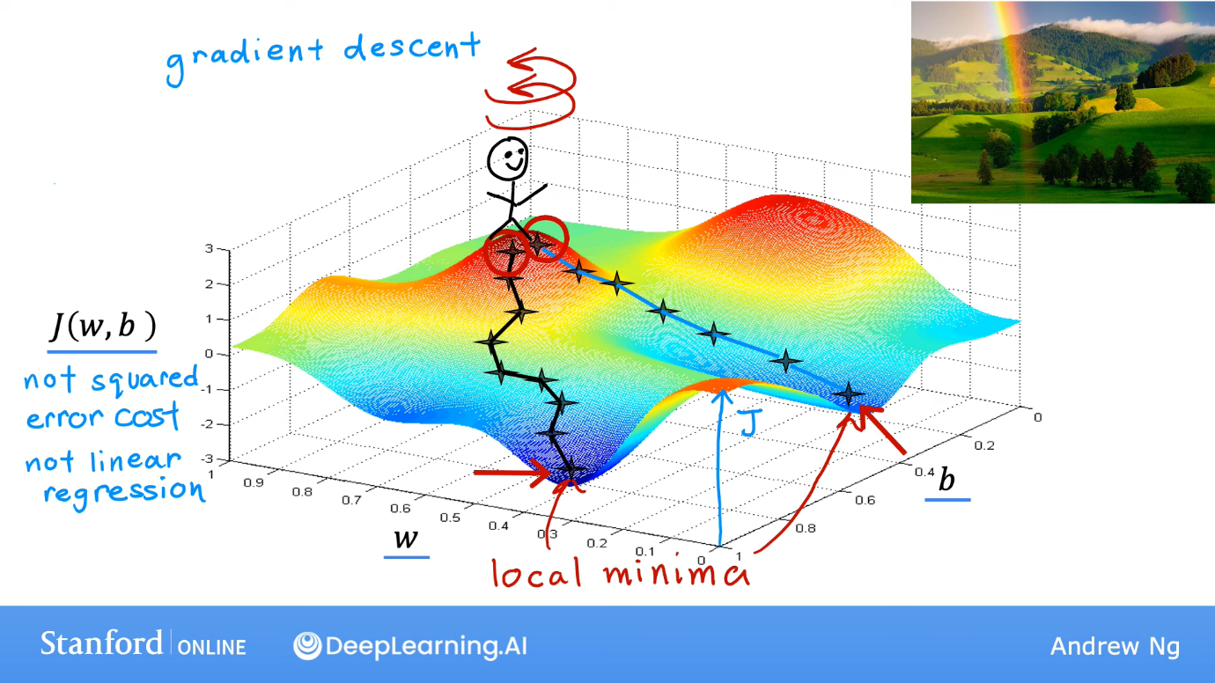

Implementation:  
 We change w and b using the following procedure (see image below). Here, α is called the **learning rate** and it is a number between 0 and 1. The smaller the α, the smaller the steps we are taking to reach the minima. And after calculating the partial derivative, we need to put the old values of w and b in it, in both the formulae (for w and b as well). Thus, we have to make a temp_w and temp_b. If we would have directly updated actual w in the first step, the new w would have gone to the second step. But, since the calculation is w.r.t the old values, thus we have to make temporary variables. This is called **simultaneous update**, i.e., updating both the values w.r.t. same set of w and b (here, the old ones).   
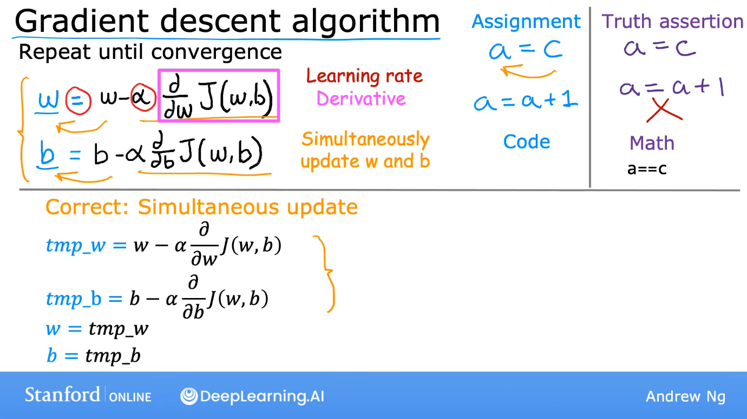  
The logic of the negative sign before the derivative is that if J is increasing with, say, w, then we need to decrease w so that J decreases as our goal is to decrease J. We have to keep repeating this process till minima is reached.

Choice of α, the learning rate:  
 If α is too small, the gradient descent algorithm will take a lot of time as it would process more steps. But, if α is too large (nearer to 1), then, imagine, if you were very near to the, say, w which corresponds to minima of J, and then you take a big step, you might increase or decrease w so much that you might cross the correct w and reach the other side (see image below). And then if you reach a new w where the magnitude of the slope (the partial derivative of J w.r.t. w) is greater than before, then in next step, w will again reach the previous side, at a point farther away and all this will keep happening as seen in image below, on the right. So, the gradient descent may overshoot and instead of converging, it might diverge.  
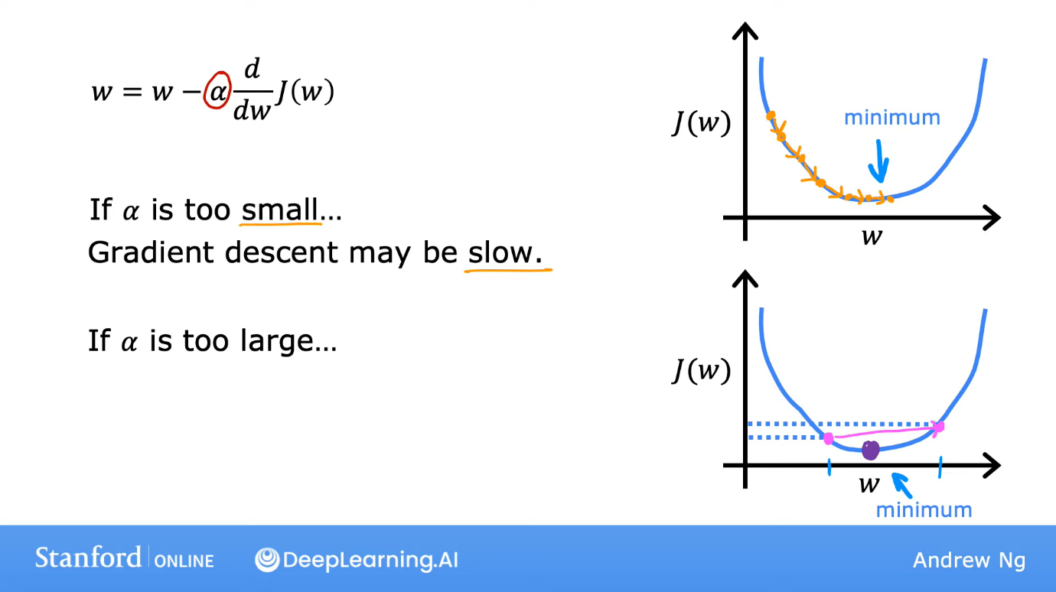 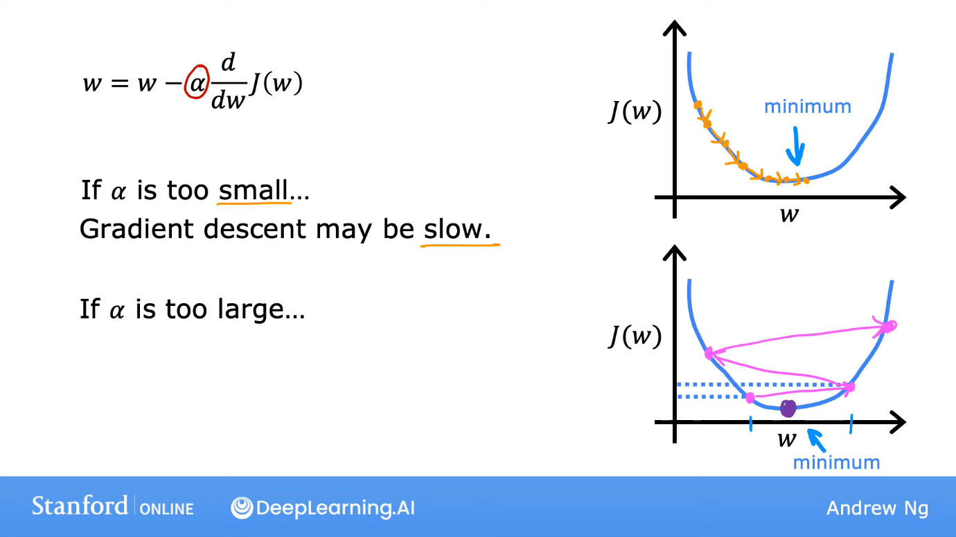

Now, when we reach the w,b pair corresponding to minima of J, then derivatives would become 0 and w and b would not change further. Gradient descent can reach the minima even with a fixed learning rate as α times the derivative would keep getting smaller and the steps would automatically get smaller as we reach closer to minima.

Let us recap the linear regression model using the image below.

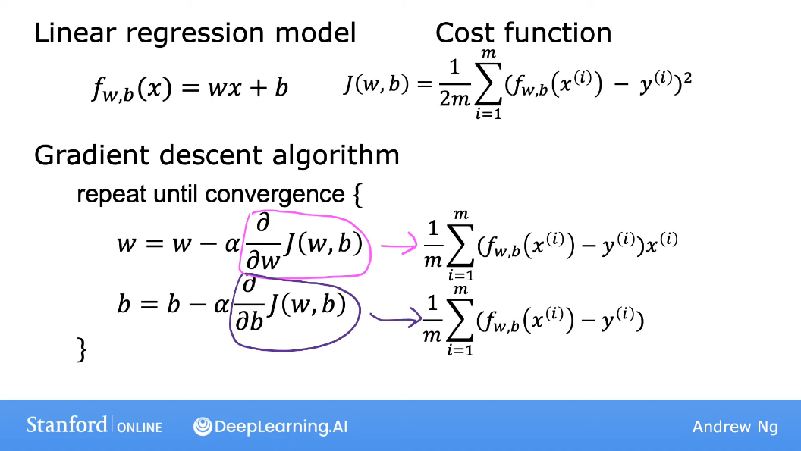

The squared error cost function is a convex function (Bowl shaped, if J is z axis, w is x and b is y axis.). So, it has only one local minima which the global minima as well. Thus, for this, we don’t need to worry that whether the local minima we have reached is the global minima or not.

This gradient descent is called **Batch** gradient descent as at every step of the descent, we are considering all the points of the training data, not its subset.

Linear Regression Model with Multiple Features (x’s)

Here, more than one feature is used to predict the label, y. xj represents the jth feature. n = number of features. (i) represents the features of the ith training example. (i) is a list of n features, usually called a vector. Xj(i) represents the jth feature of the ith training example.

Model: fw,b(x) = w1x1 + w2x2 + … + wnxn + b  
To write it in a better way, we use vectors.  
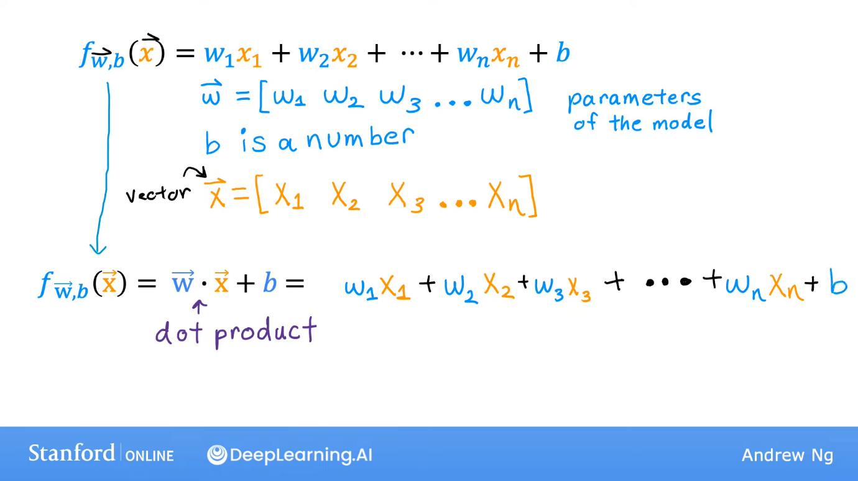  
This model is called **multiple linear regression** (not multivariate regression. That means something else).

**Vectorisation** It helps us to make the code clearer and run it faster.  
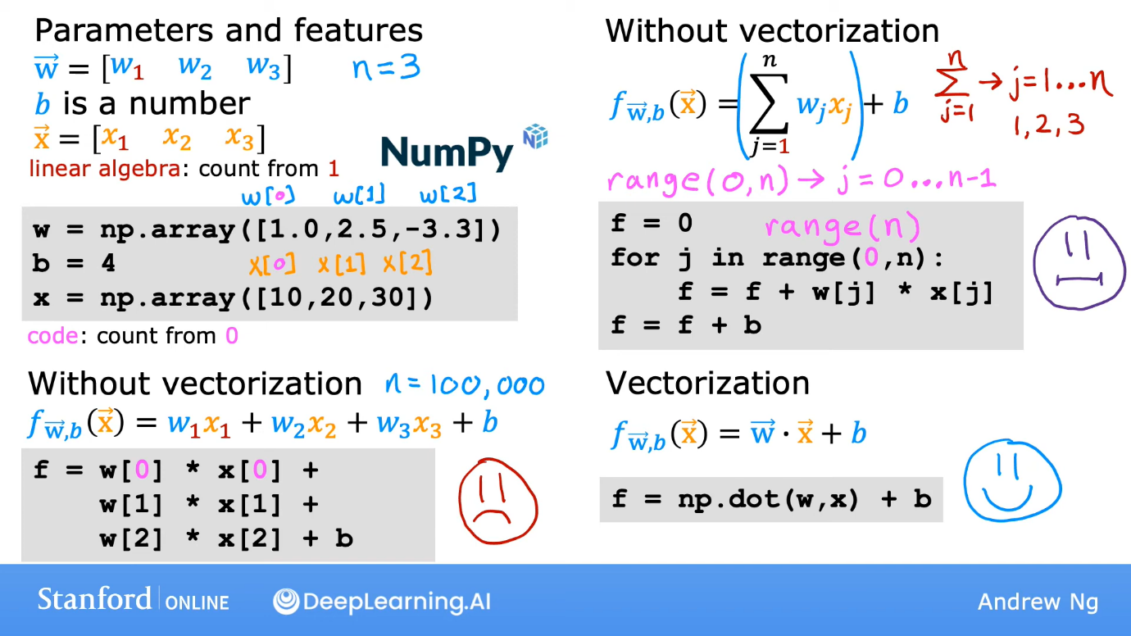  
In maths, we start the count from 1, but in coding, we start it from 0. These vectors are implemented using the NumPy library which we have to import first. It makes the code much more efficient. NumPy uses parallel hardware which makes the code run faster than the for loop, that uses sequential calculation.  
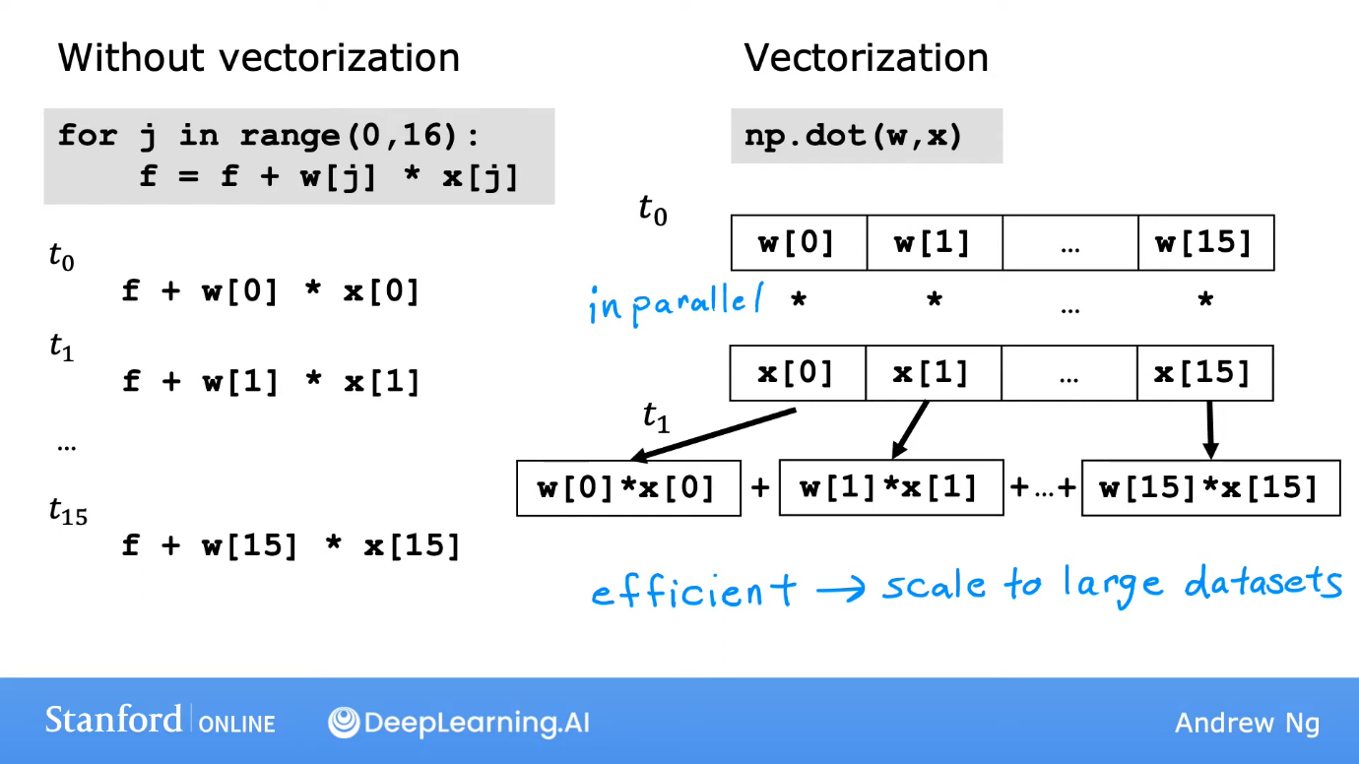

When, we do gradient descent using vectors, calculations for all the features (x’s) happens simultaneously (parallelly) and thus saving time and space (as we didn’t have to make temporary variables).  
  
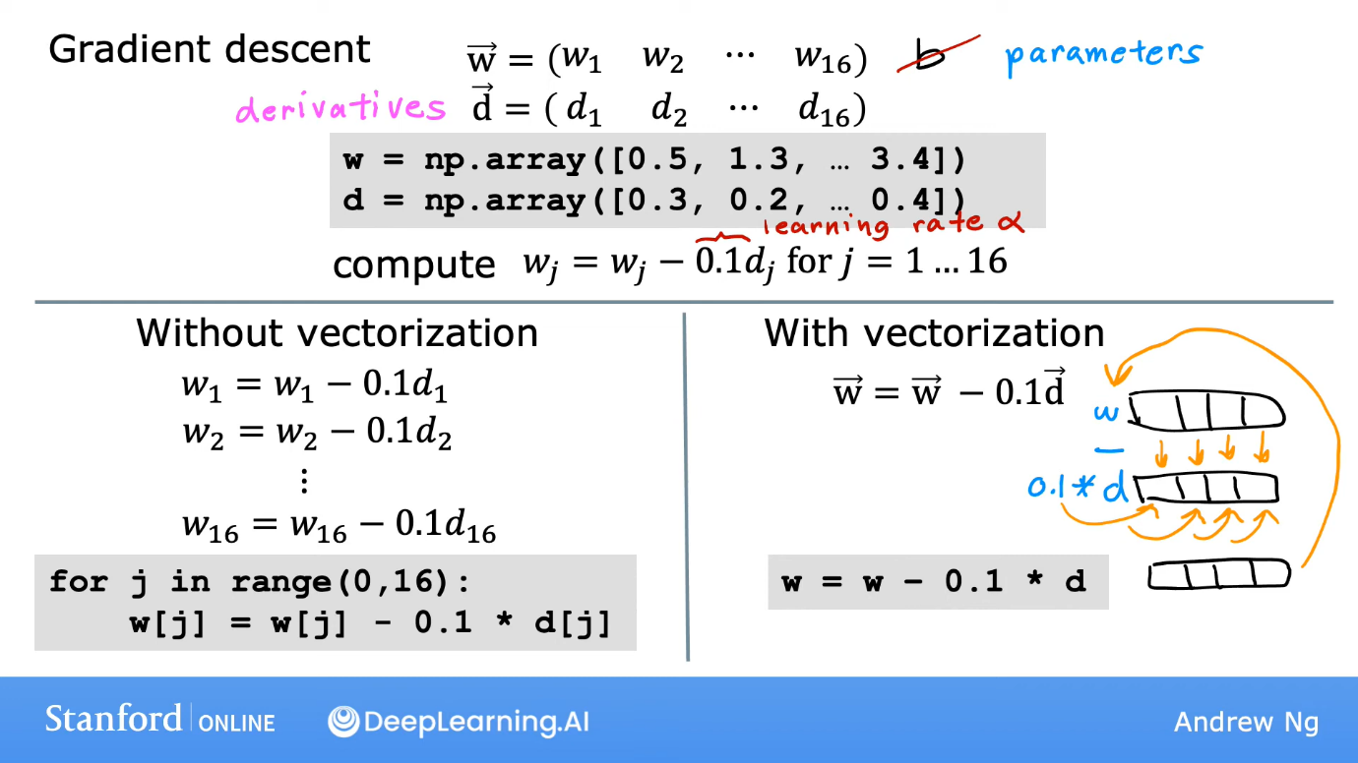  
**___________________________________________________________________________  
Gradient descent in multiple linear regreseeion:**  
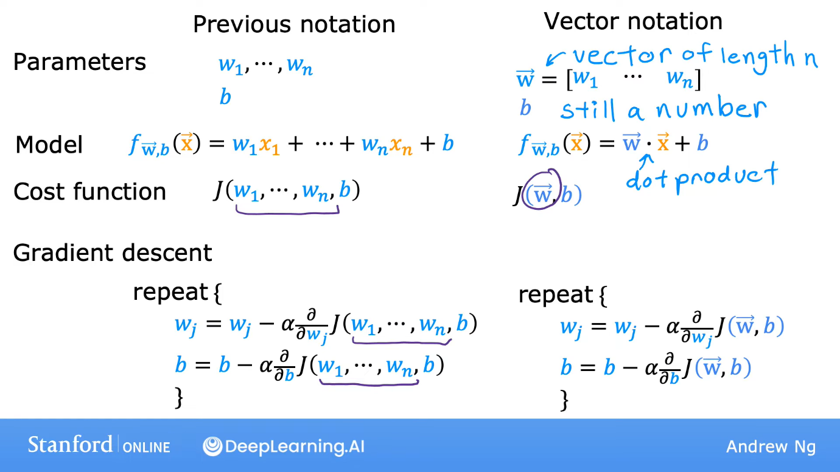 **___________________________________________________________________________**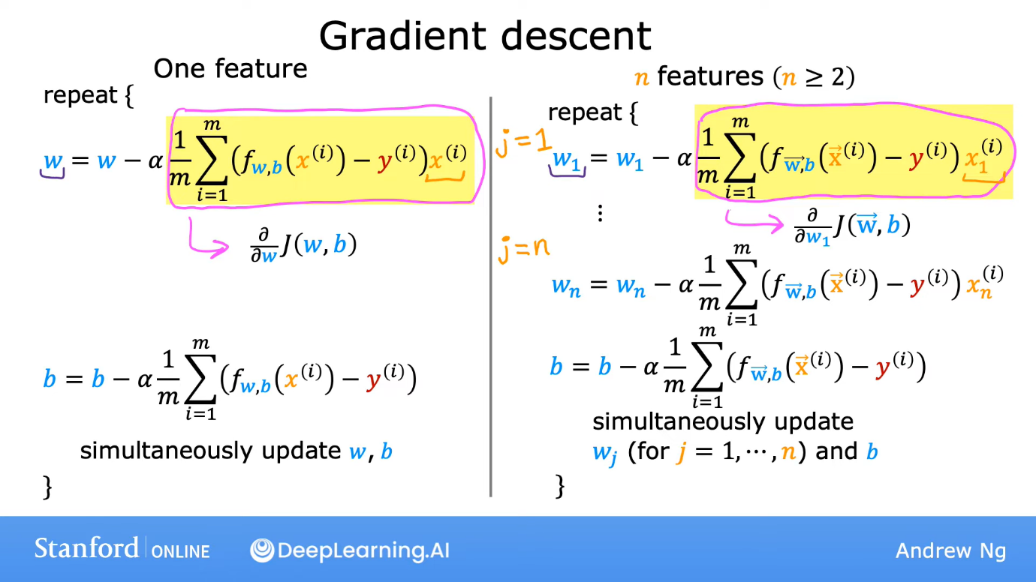

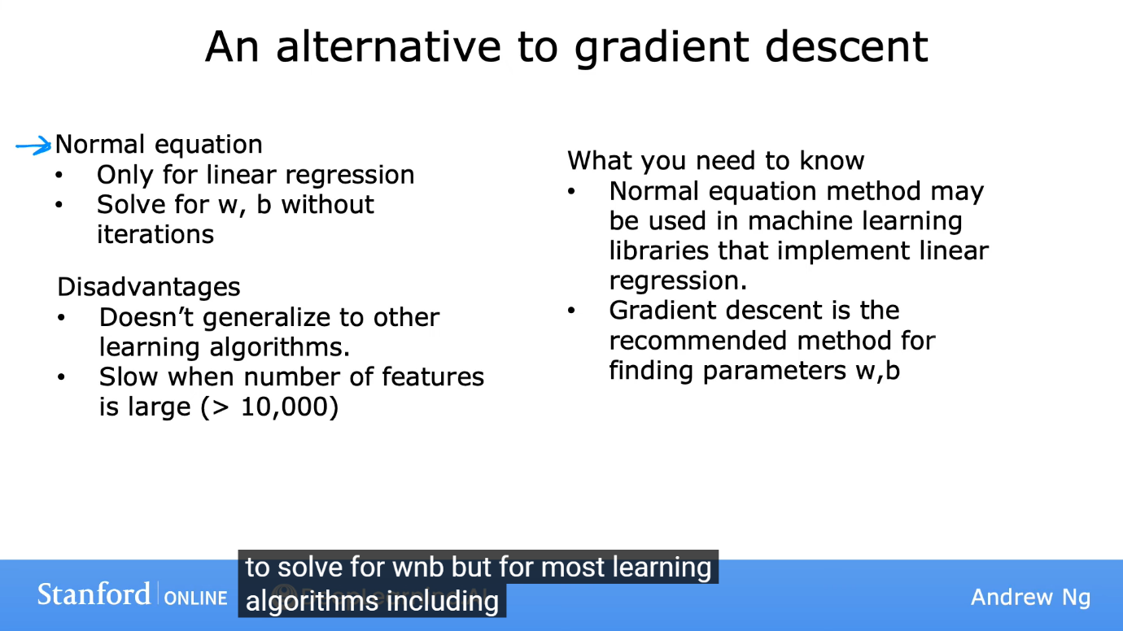  
If we are using a mature ML library, there is a chance that the library would be using this normal equation for linear regression problems.

Feature Scaling

This makes gradient descent much faster. We can scale features using methods like Dividing by maximum, mean normalisation, Z-score normalisation.

For example, let a model be made for estimating the price of a house. It has features like number of bedrooms (x1), age of house (x2), area (x3). Here, the parameter b would be the base price (since if all x’s are 0, then b is the price). Say, if x1 varies from 0-5 and x3 varies from 0-2000 sq.ft., then a logical approach would be to keep the guess for w1 small and w3 big. As if the no. of bedrooms increases even by one, the price should increase much more than if the area increases by 1 sq. ft. Thus, logically, the features (x) which vary more, should have smaller corresponding parameter (w). But, during gradient descent, even a small change in w3 would bring a big change in J and it might increase the value of J further (by crossing the minima and going to the other side, like the logic we saw if we take a big value of the learning step alpha).  
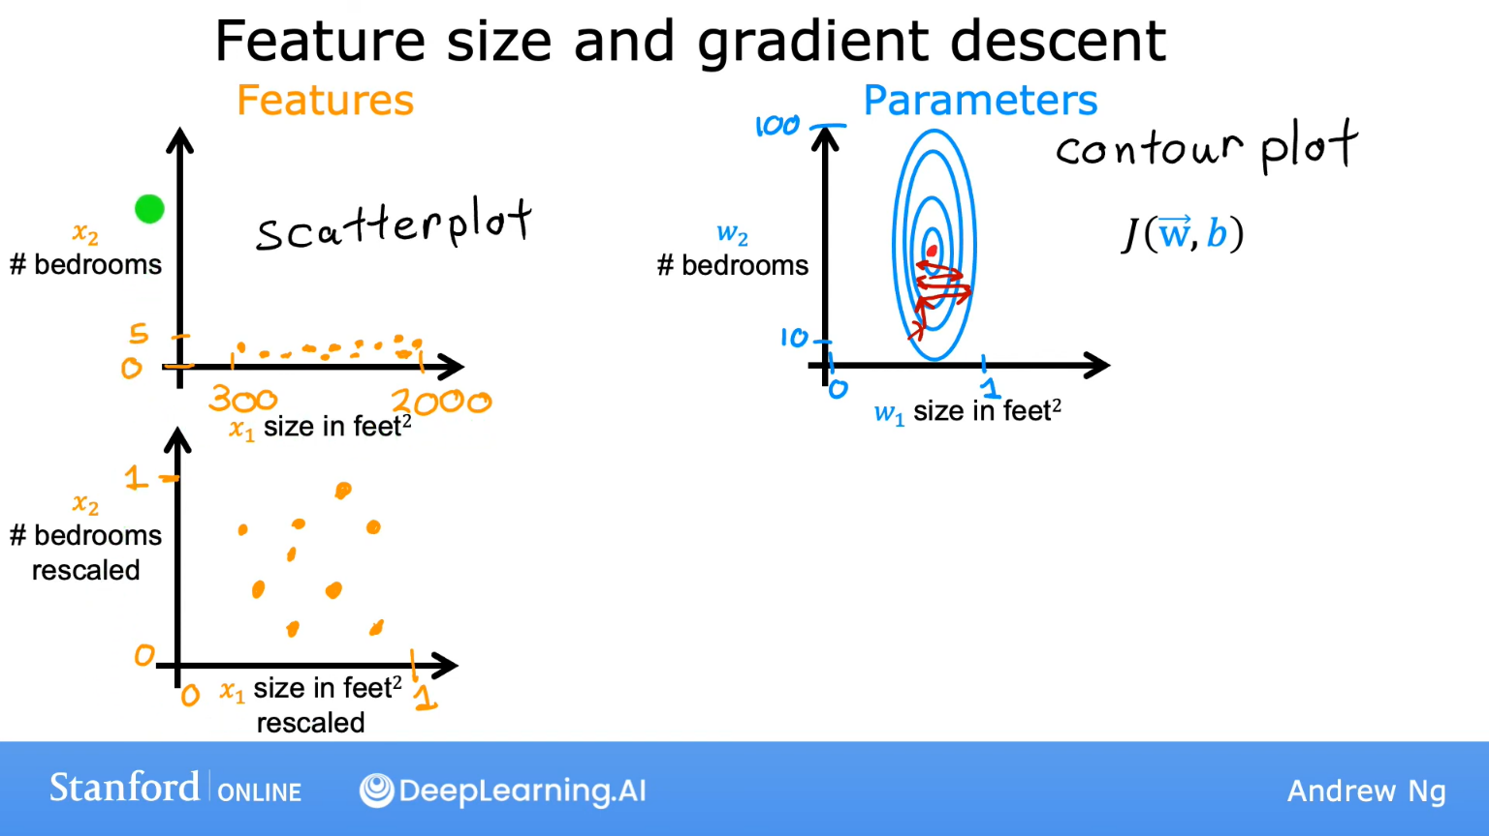  
Thus, we scale the features so that even the more varying feature varies less on the scale or the less varying feature varies more, so that they both vary almost equally. This makes the algorithm faster and reach the minima in a more direct way, as seen in the images below.  
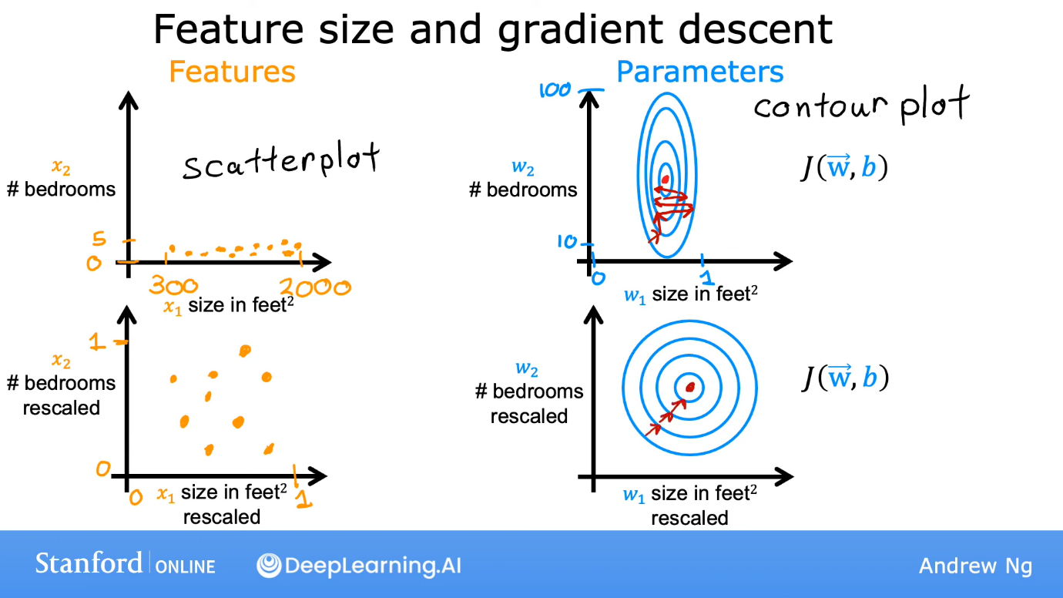

We can scale things by dividing all the features by their maximum value. Eg:   
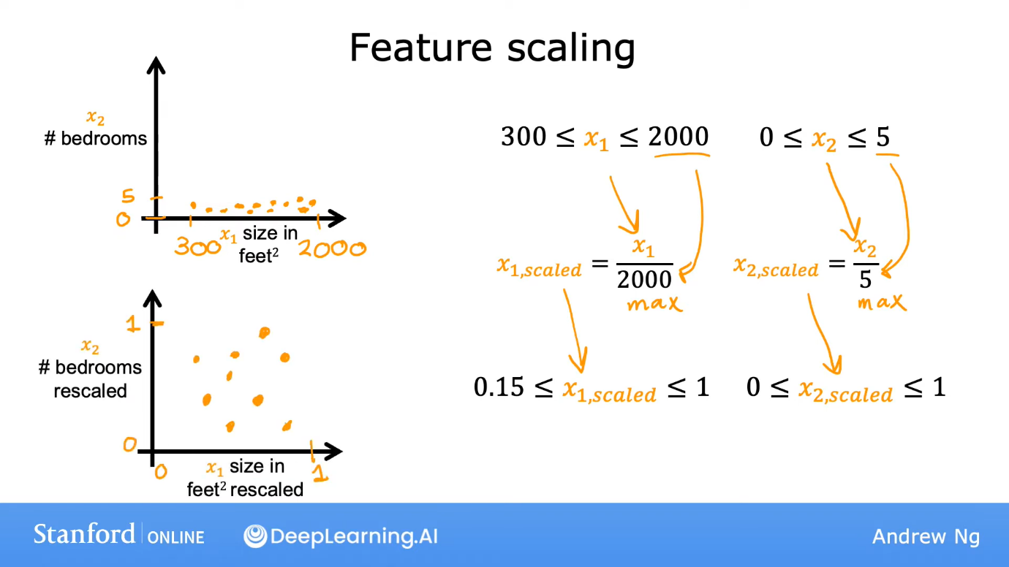  
Now, all features would vary almost equally.

Instead of dividing by the maximum amount, we can do **mean normalisation**, which leads the data point to be centred around 0. To do this, we take the mean of all data points in the training set for the feature and proceed as seen in the image below.

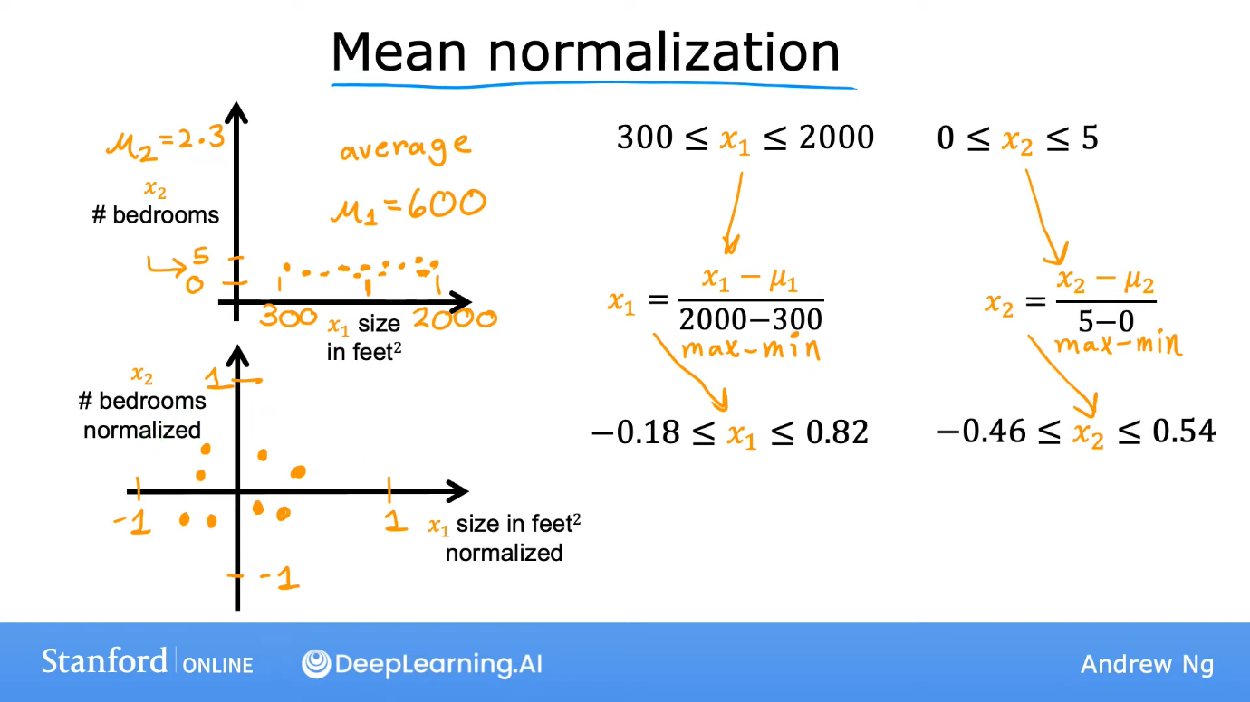

We can also use another method called Z-score normalisation. In this, we calculate standard deviation and mean of the data set for all features and proceed as follows:  
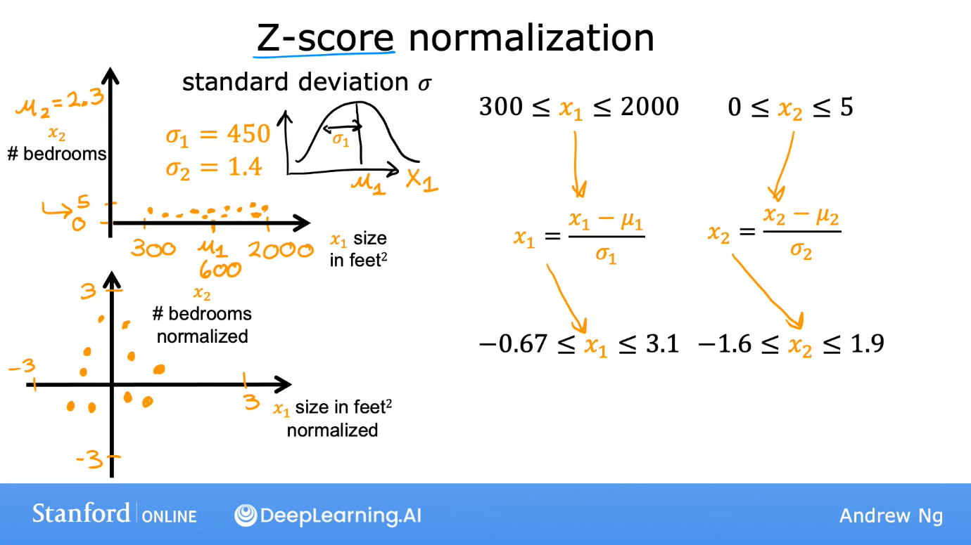  
**___________________________________________________________________________**  
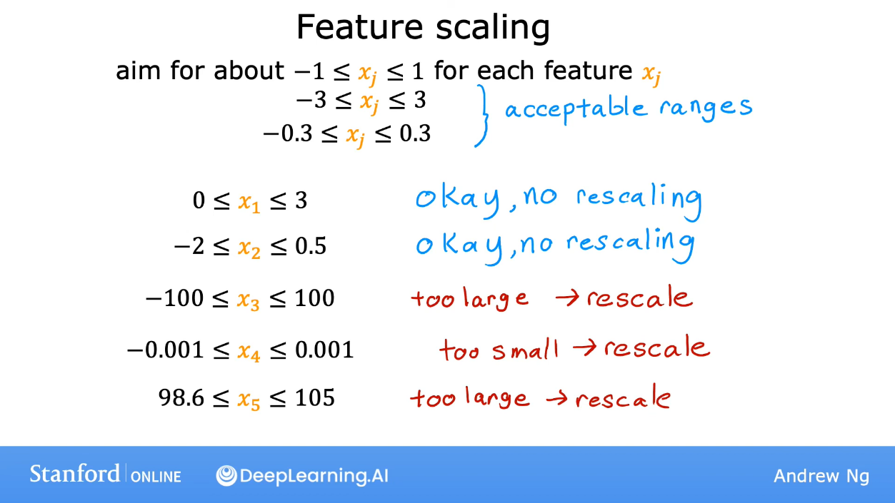

**Graph (Learning Curve)**  
The graph in which y axis is J and x axis is number of iterations (while doing gradient descents) is called learning curve. For a good gradient curve, the slope of curve should be negative (so that J decreases). At the end, slope should become 0, when minima is reached and we say that the gradient descent has converged. The number of iterations (descents) needed to converge differs on the application.

**Automatic convergence test**  
Let ε (epsilon) be 0.001. If J decreases by <= ε in 1 iteration, we declare convergence. Here, it means that we have found the w and b which make J very close to the minima. Choice of ε depends on the case.

**Choosing the correct learning rate (α)**  
If the learning curve is as follows, then it means that either there is a bug in the code or α is too large.  
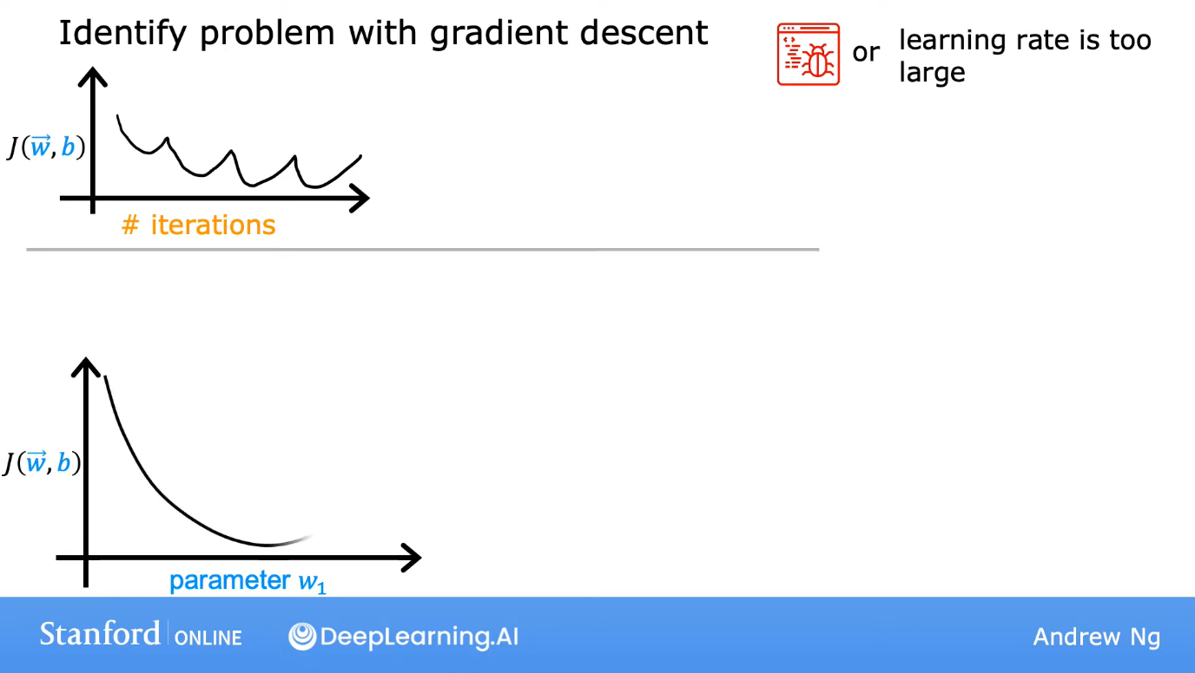 or 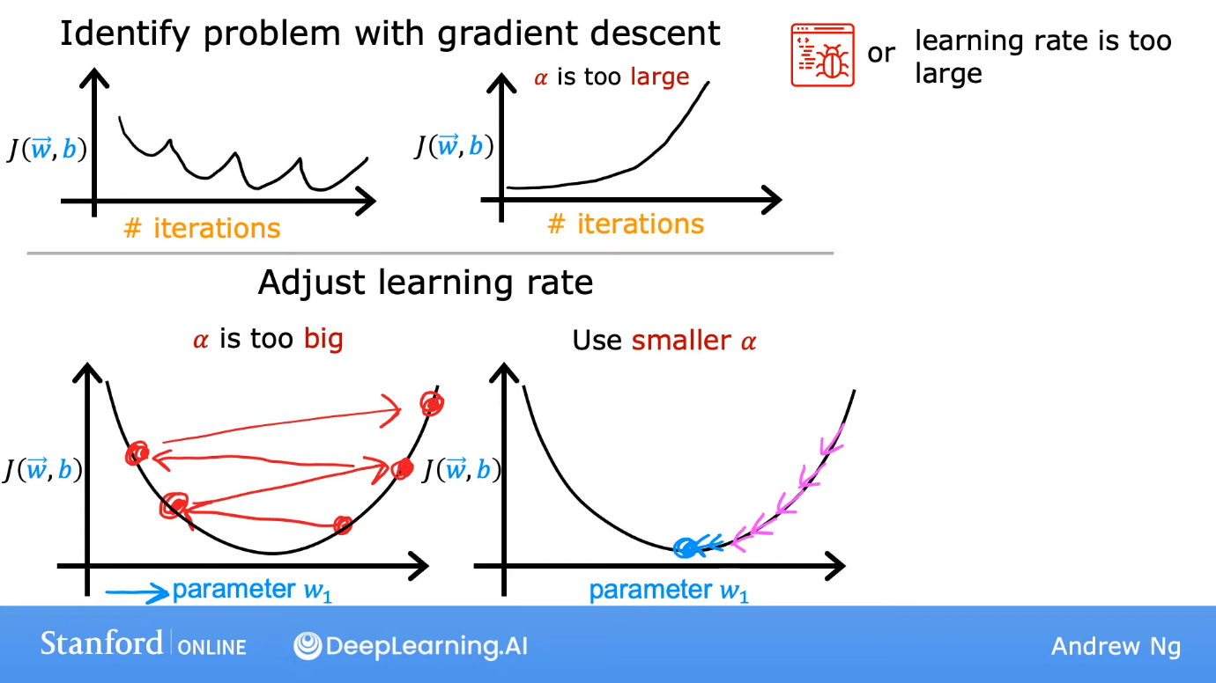  
If you are getting such a learning curve, first make α very small. If the curve becomes good, then it means that problem was that α was too big. But, if the graph is still bad, it means that there is a bug in the code.  
To get the correct alpha, we start with a small alpha like, 0.001 and then we plot the learning curve for a few iterations. If its good, then we increase the alpha to say, 0.001 and then again plot the curve and then set alpha to 0.01 and so on. Take the alpha which makes the learning curve have highly negative slope and also consistently negative slope.  
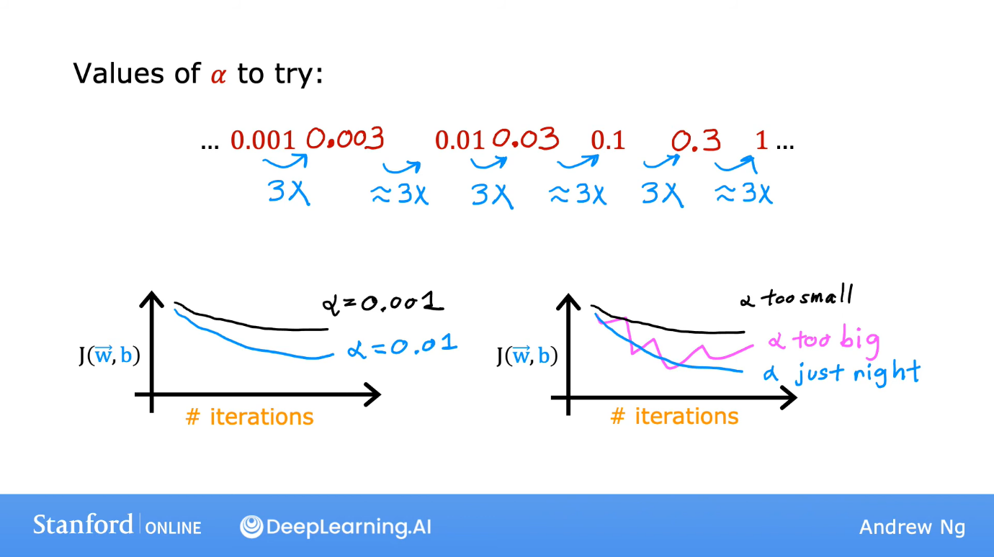

**Feature Engineering**  
It’s the skill to choose the correct and most appropriate features.

Polynomial Regression

For example, in the following image, it would not be good to choose a linear graph. So, we may choose a quadratic graph. But it starts coming downwards later. Thus, we may decide to choose a cubic regression. In the cubic regression, the feature vector has 3 elements, x, x2 and x3. (A better model might include the features x and sqrt(x)).  
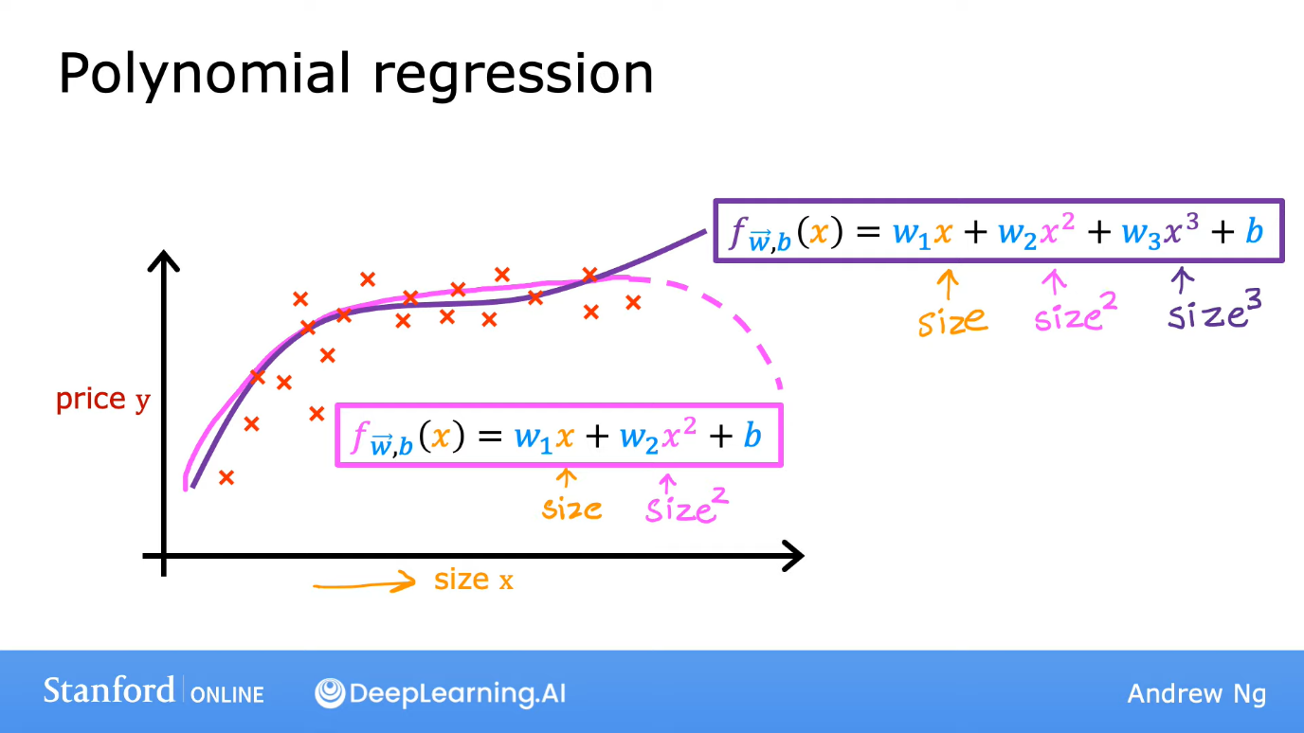  
In polynomial regression, feature scaling becomes an important factor as if x varies from 1 to 1000, then x2 would vary from 1 to 106.

**Classification**

Linear regression is not a good algorithm for Classification as we want to get discrete categories, not infinitely many possible numbers. We prefer **Logistic regression** for classification. Even though this term has “regression”, but it is used for classification.

For yes or no questions, the class no is called negative class and is represented by no, false or 0 and on the other hand, yes is called the positive class and is represented by yes, true or 1. Negative and positive don’t necessarily mean bad and good, they just mean absence and presence.

Logistic Regression

For logistic regression, we usually use sigmoid function, a.k.a., logistic function. First, we apply linear regression and store its output in z and then apply logistic regression to z.  
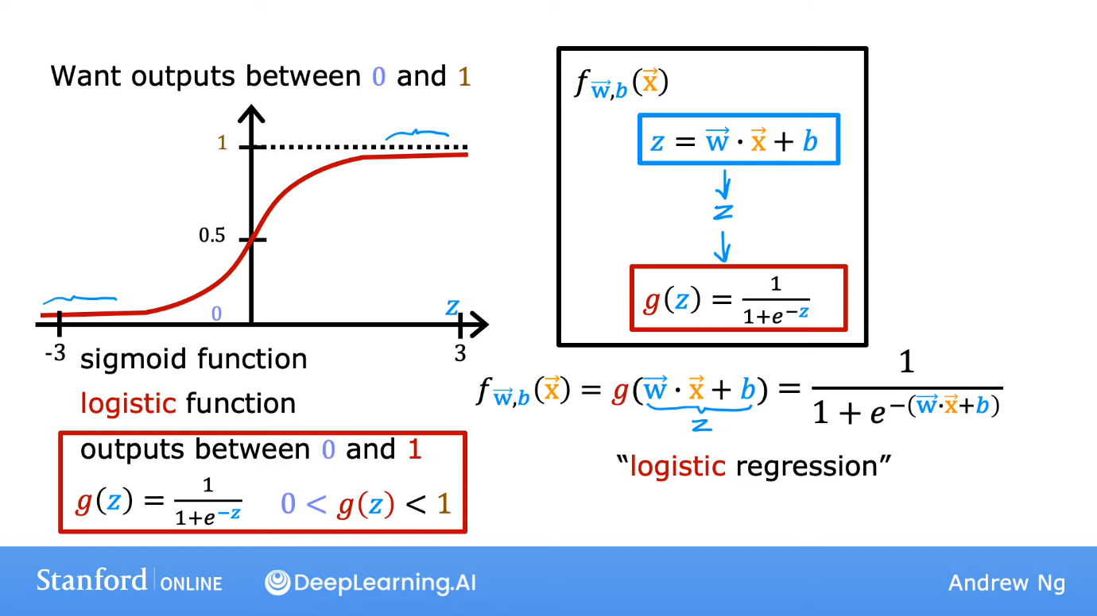

**Interpretation of logistic regression output**  
If the output is 0.7, then its interpreted that there is a 70% chance of the class being 1 and the rest 30% chance of the class being 0. In the following image, f is the final model of logistic regression.  
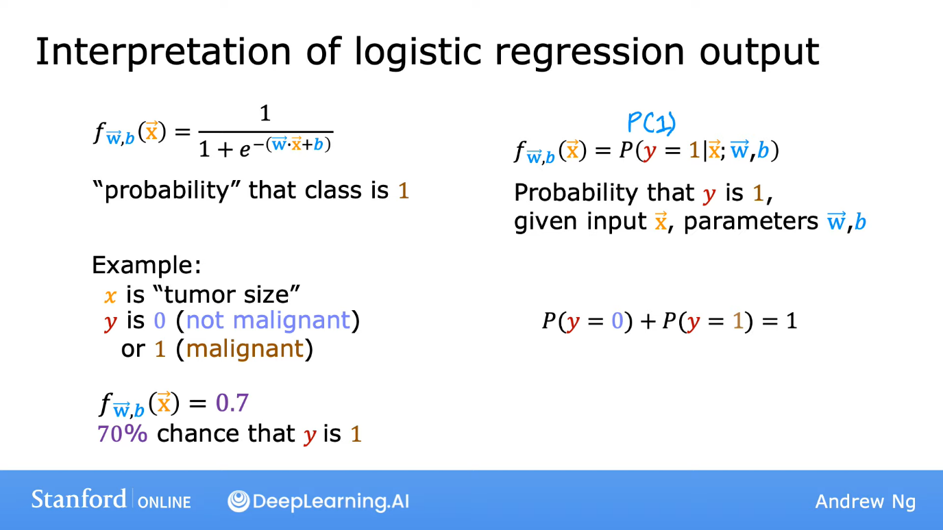

**Decision Boundary**  
We have to pick a threshold value (between 0 and 1) such that if f(x) (prediction done by logistic regression (between 0 and 1)) is above the threshold, then ŷ is 1 and if its less, then ŷ is 0 where ŷ is the predicted value. We usually choose the threshold as 0.5.  
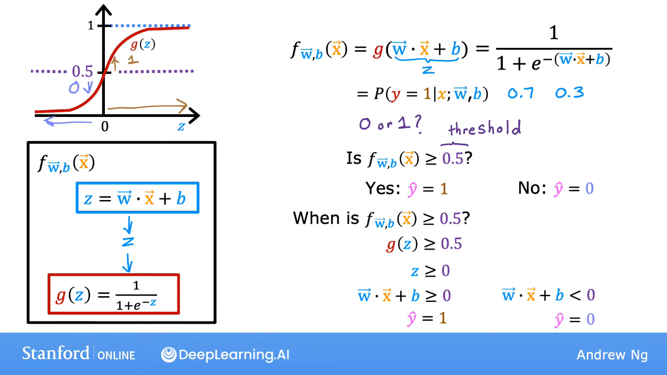

Example: (This has two features)  
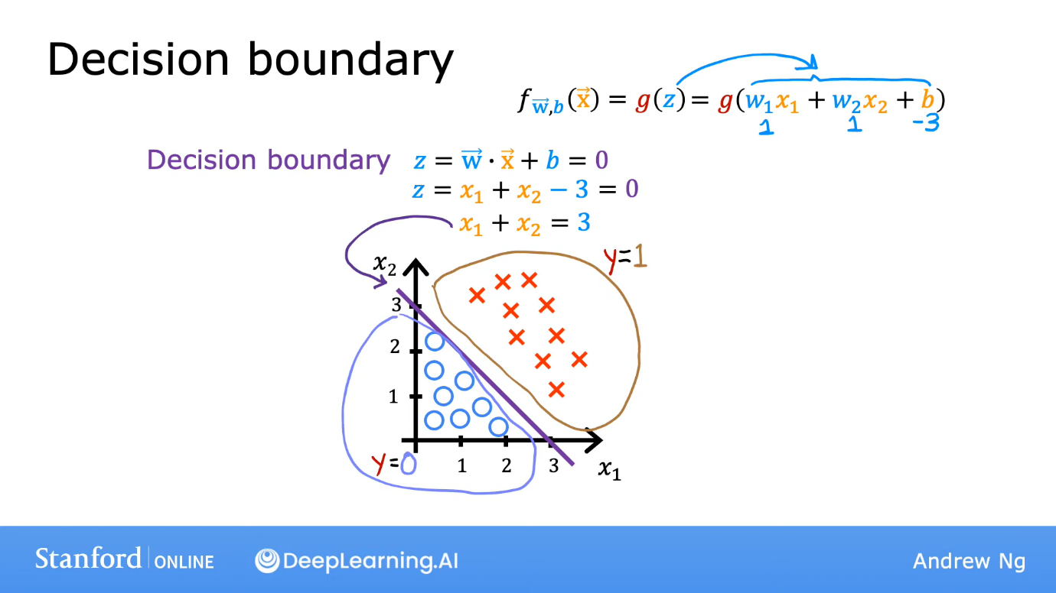  
Example:  
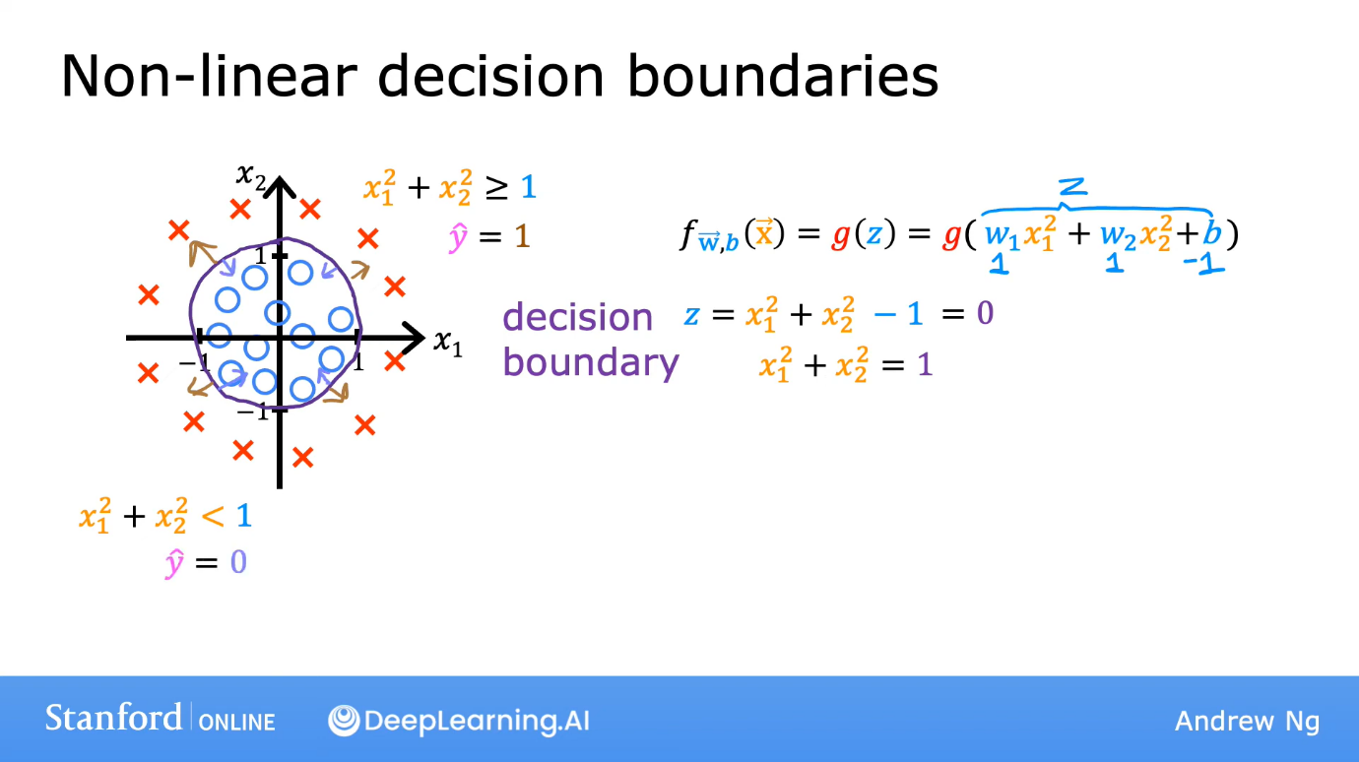  
We can have complex decision boundaries like:  
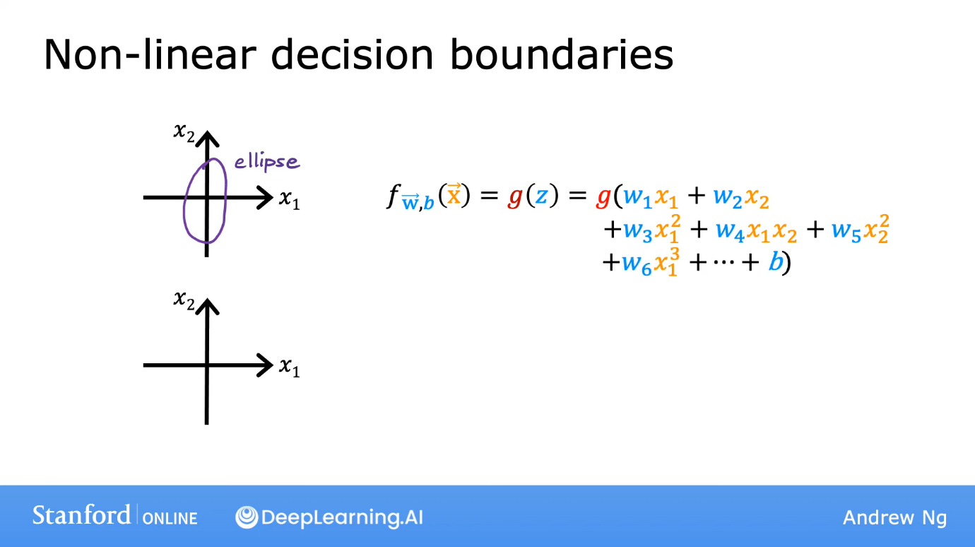

**Cost function for Logistic regression model**  
The squared error cost function is not a good cost function for logistic regression. Recall that when we plot squared error cost function for linear regression, we get a parabolic graph if we plot J in y axis and one of the coefficients (w) in x axis. But, for sigmoid (or logistic) function, if we plot such a graph, we get a non-convex graph which looks as follows.  
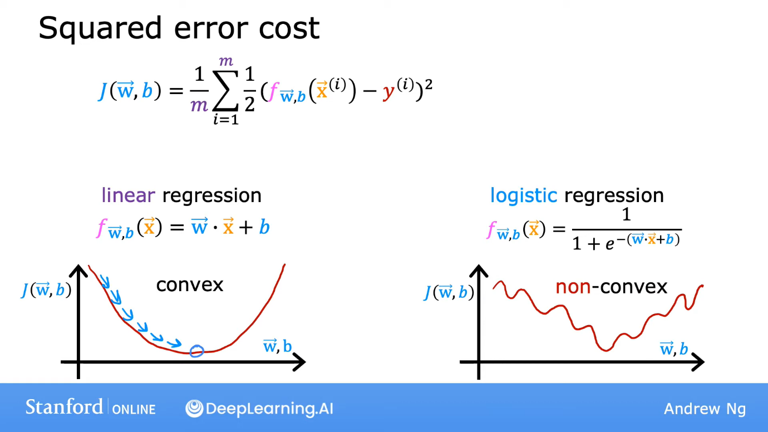

There are a lot of local minima in the graph here (on the right). Thus, the gradient descent for the squared error cost function might up in a local minima which is not a global minima.

Loss function (L(f(x),y)) is the function of f(x) and y which is inside the summation. The “summation of L(f(x),y)” divided by m gives the cost function. So, the loss function for linear regression’s square error cost function was:  
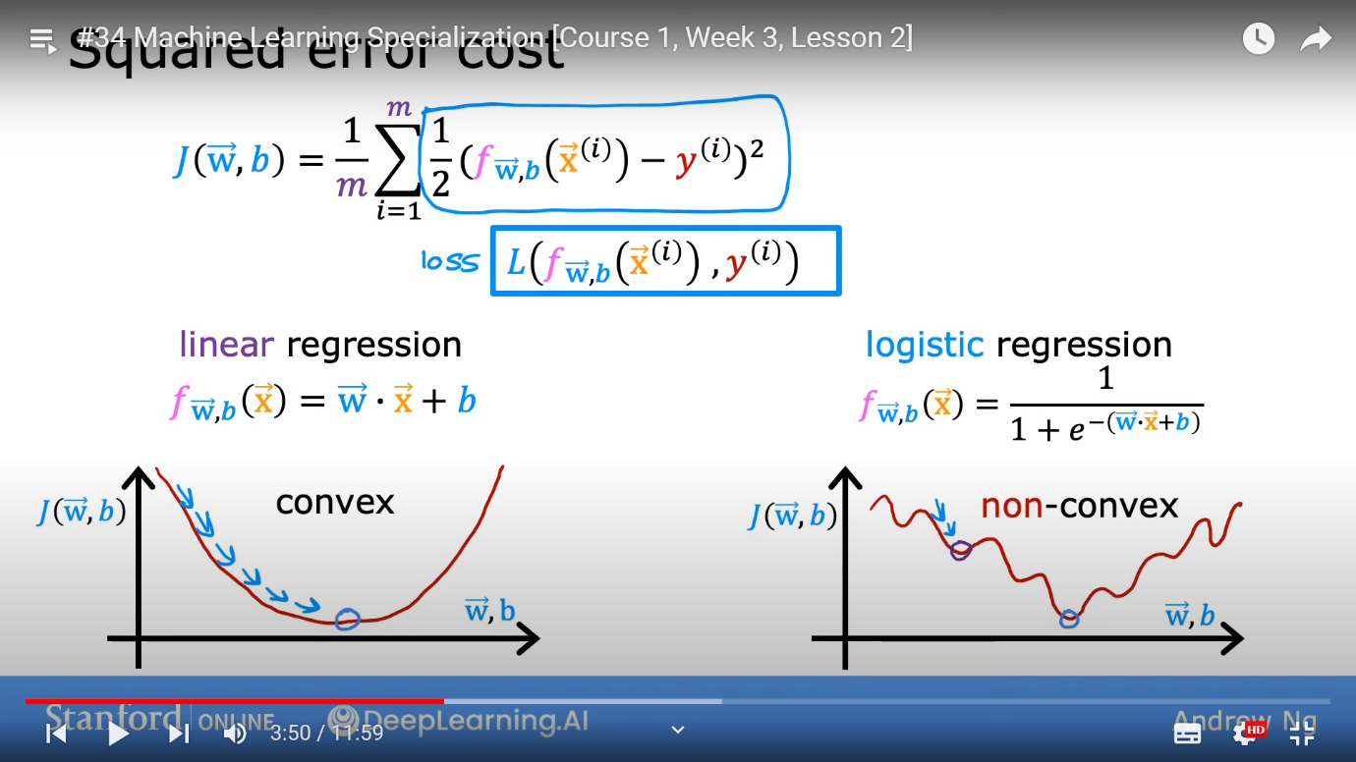

For, logistic regression’s cost function, we use the following loss function.  
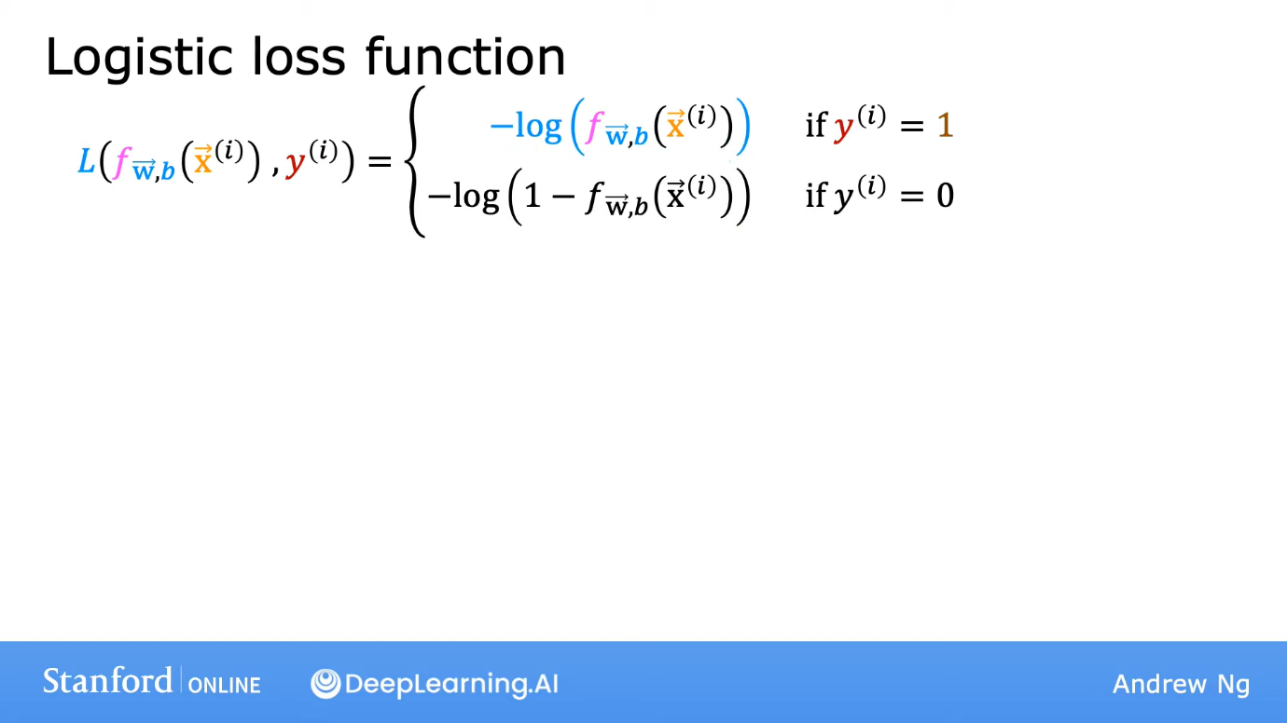  
Reason to choose such a loss function:  
When y is 1, the loss would be 0 when f is 1, but it should be extremely high when f is nearer to 0. Thus, this loss function is a good choice.  
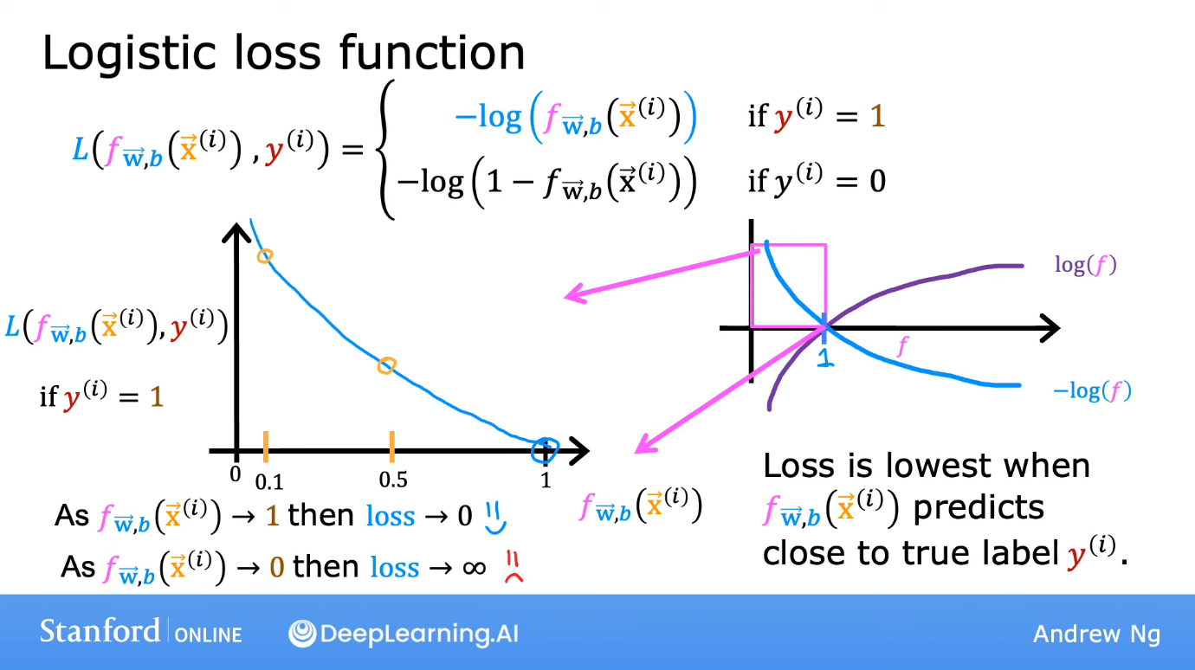  
Similarly, when y is 0, the graph of L vs f is as follows:  
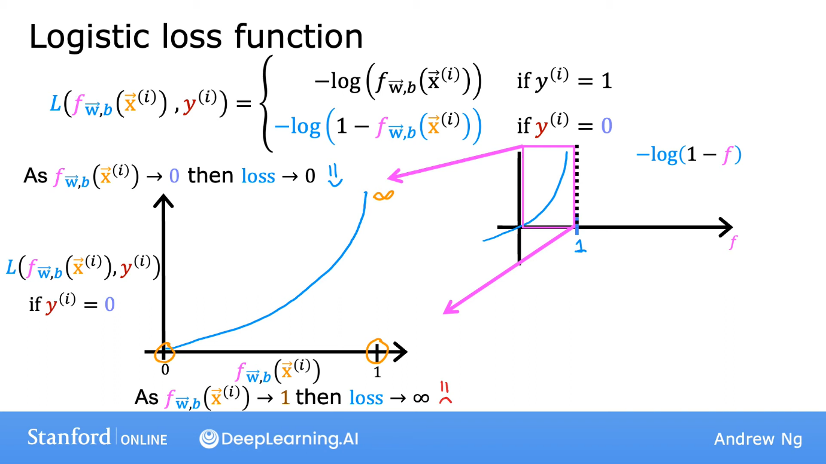

Thus, the preferred cost function (which is convex) for logistic regression model is:  
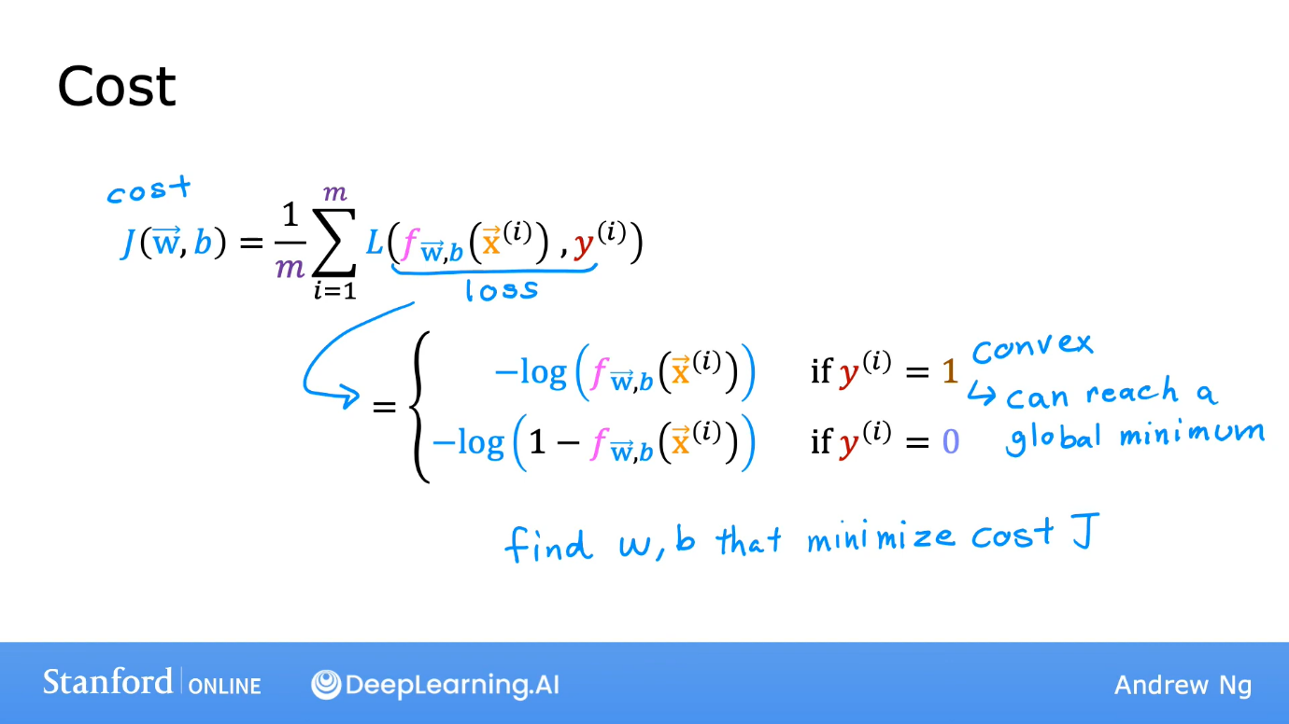

**Simplifies loss function**  


As y is 0 or 1, so only one out of these 2 terms will remain.  
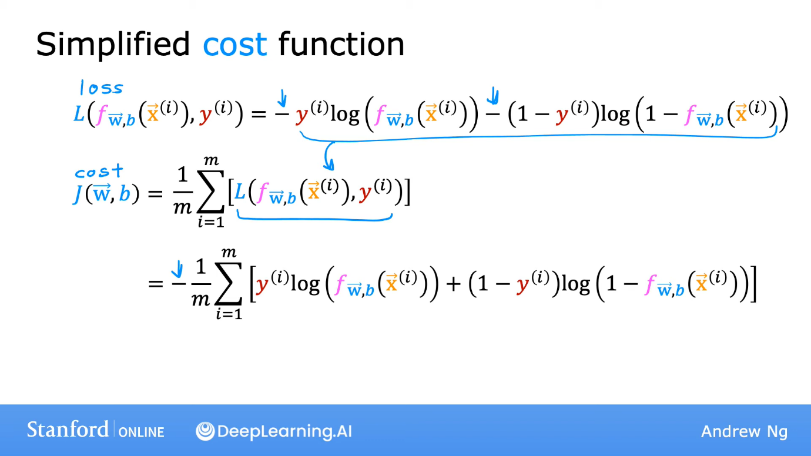

**Why did we choose this loss function?**  
This has been derived from a concept in statistics, which is maximum likelihood estimation.

**Gradient Descent for finding parameters for logistic regression**  
On calculating, we get the following.  
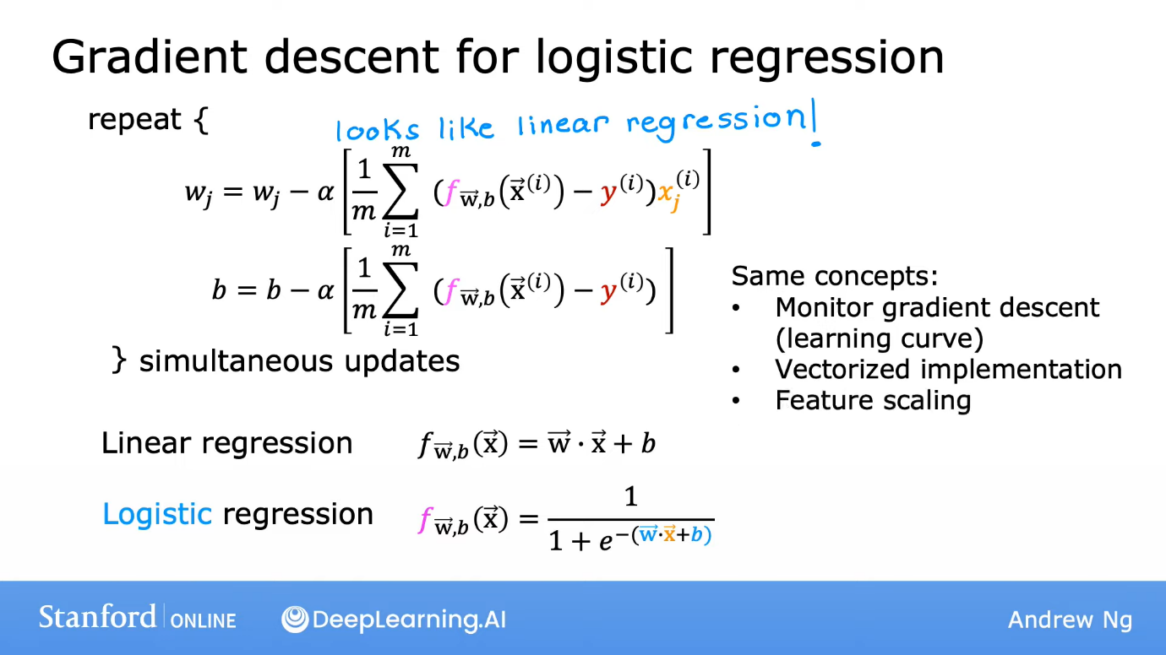

All the logic is same as that for linear regression, just that f(x) is different.

**The Problem of Overfitting**

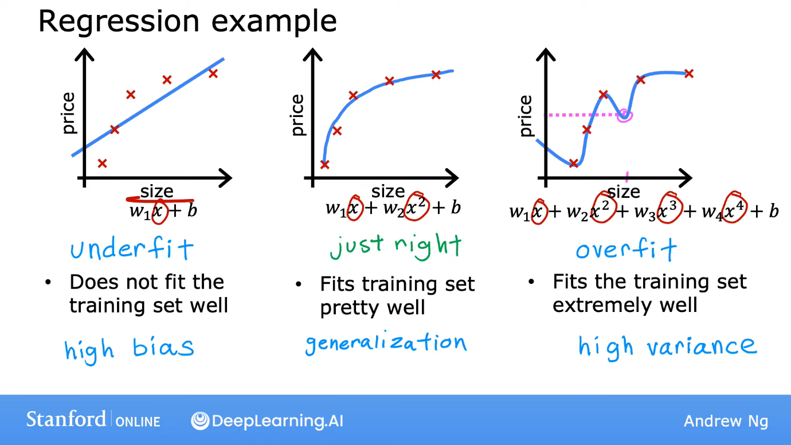  
Both, underfit and overfit are bad. The problem  
 with overfitting is that even though it exactly passes through all the points of the training set, but it has random hills and valleys which may predict the wrong answer. If you give the same code two different training sets and the code overfits both of them, then the f(x) received from both of them would vary a lot, hence the name high variance is given to overfit. Let’s see a similar example for classification.  
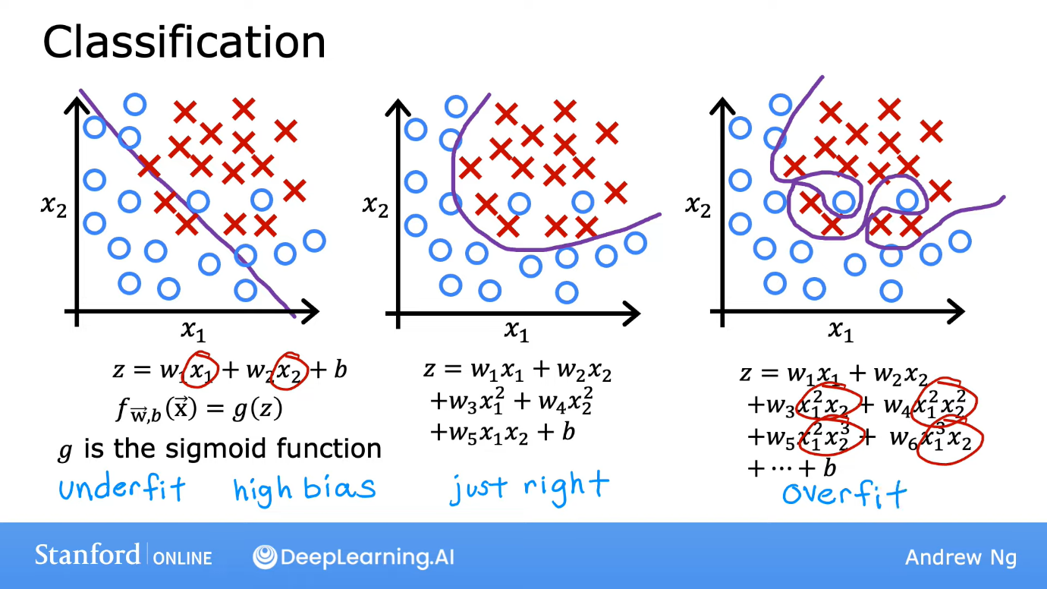

**Ways to correct overfitting**  
1. Collecting much more training examples. This is a good way. But it is not possible if much data is not available.  
2. Feature selection: Select features to include/exclude. Exclude things that do not matter much. Disadvantage: It may ignore important things.  
3. Regularisation: Reduce the value of parameters (w) of less important features instead of completely excluding them. Eg. is f(x) is a biquadratic polynomial, then reduce the w corresponding to x4 and x3. This method is very important.

**Cost function with regularisation**  
If we have a lot of features, we penalise all of them. By penalise, we mean that reduce its parameter (w) by a great extent.  
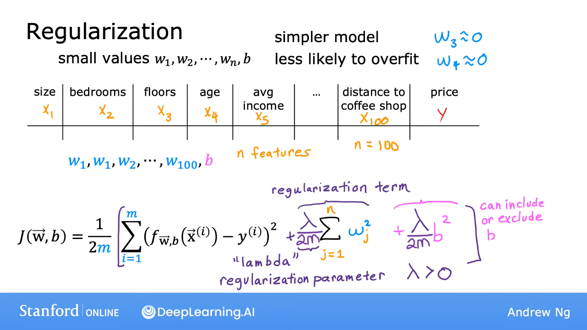  
This is the way of regularisation. Since, J is a function made to find all the w’s and b such that J is least, thus, by adding regularisation terms, w’s and b will have to be less so that J is less. We usually do no add the b2 term as it doesn’t make much difference usually. We have to choose a lambda which balances the situation well.  
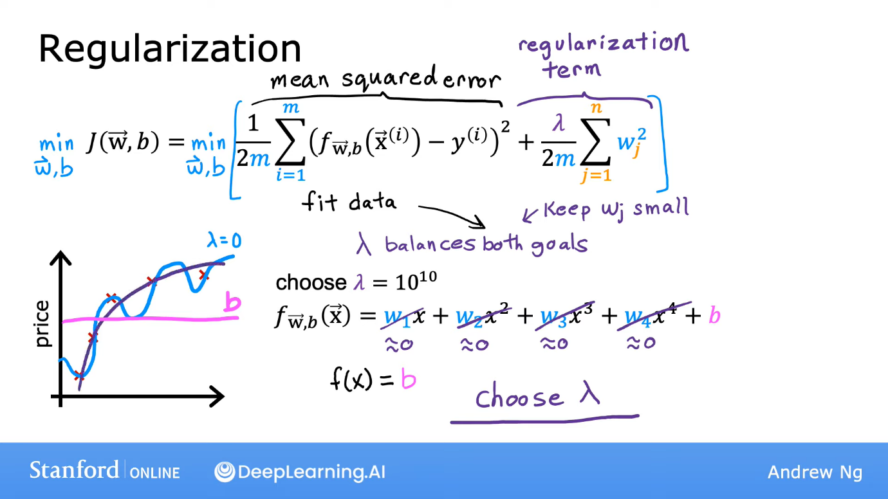  
If we keep lambda too low, the data will get overfitted. If we keep it too high, f(x) would almost become a closed function.

